---------- Forwarded message ---------  
From: **HOME RESIDENTS ASSOCIATION** <[homeresidentsassociation@gmail.com](mailto:homeresidentsassociation@gmail.com)>  
Date: Wed, Aug 5, 2020 at 10:47 AM  
Subject: Re: Croydon's environment and health - Urgent stop the tree works in Havelock Rd, Addiscombe  
To: Canneaux, James <[James.Canneaux@croydon.gov.uk](mailto:James.Canneaux@croydon.gov.uk)>  
Cc: Henson, Maddie <[maddie.henson@croydon.gov.uk](mailto:maddie.henson@croydon.gov.uk)>, Bains, Jeet <[jeet.bains@croydon.gov.uk](mailto:jeet.bains@croydon.gov.uk)>

Good morning

I am writing to you on behalf of our HOME Residents Association as I was told  you can help with stopping the pruning and pollarding of trees in our roads until winter.

Below you will find a trail of emails - we have lost over 15  trees recently due  to unexplained disease or damage by vehicles. Our roads have become extremely busy due to the traffic displacement scheme in Addiscombe West. We are desperate to get more trees and also want to look after the few mature trees we have. The first photo is of Havelock today. Second is Ashburton Road after the pollarding was done.

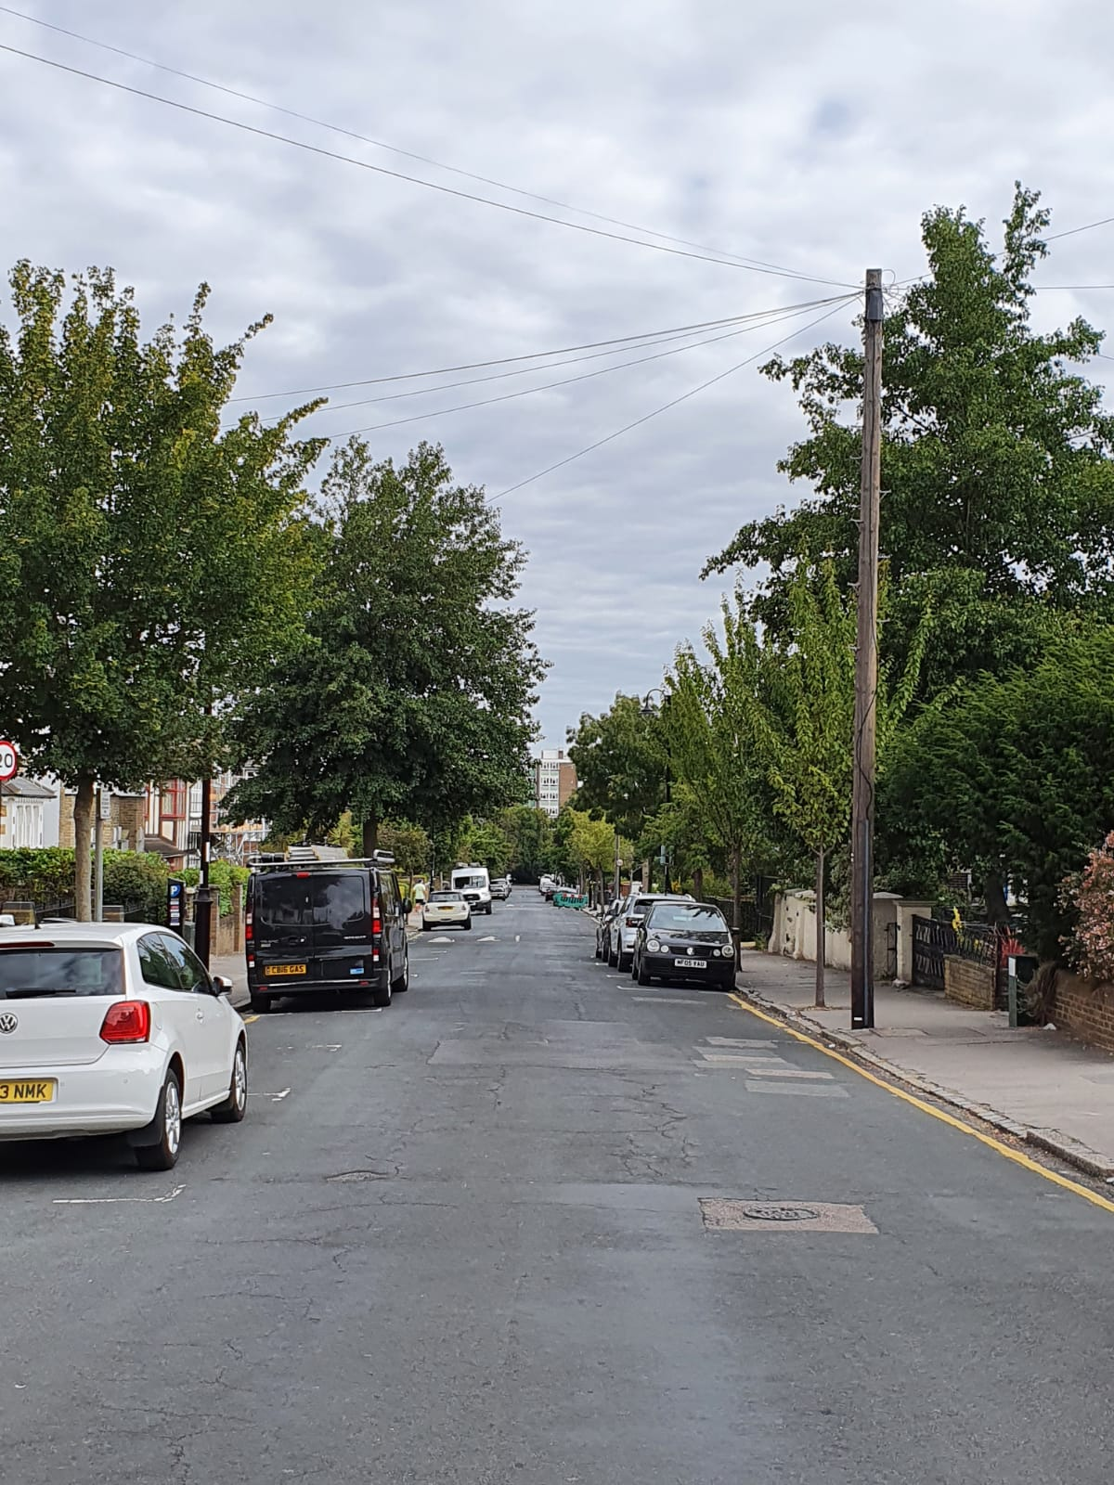

Below is Ashburton Rd, today 5th August

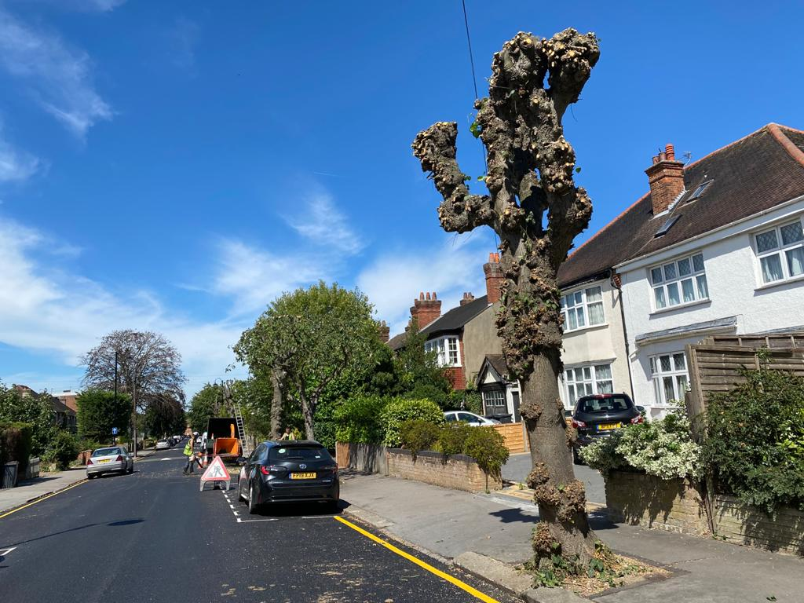

We are very unhappy and will do anything to stop this happening to our trees at the moment.

Or at least stage it so that we do not loose all the tree canopy in the same season.

I would appreciate your response before the end of the day today.

Yours sincerely

Mira Armour, Chair

On behalf of the H.O.M.E Residents' Association

[www.home.addiscombe.net](https://nam05.safelinks.protection.outlook.com/?url=http%3A%2F%2Fwww.home.addiscombe.net%2F&data=02%7C01%7C%7Cd13b6168efcc410d5cf508d839273983%7C84df9e7fe9f640afb435aaaaaaaaaaaa%7C1%7C0%7C637322187916294991&sdata=9pThL79iYlNnyl2z%2Bkq%2B6oIqzE6re3c0492tylJ4JA0%3D&reserved=0)

email: [homeresidentsassociation@gmail.com](mailto:homeresidentsassociation@gmail.com)